6th Annual
NEWBERG BOOSTERS GOLF TOURNAMENT
Sunday, August 20, 2023 Chehalem Glenn Golf Course, Newberg
Team of Four $500 or Individuals $125 9am Shot Gun Start
Includes Range Balls, Lunch & Cart

Not A Golfer? No Problem!

Scan to Learn More
Cornhole Tournament
$50 2-person Team 11am Start
Includes Lunch

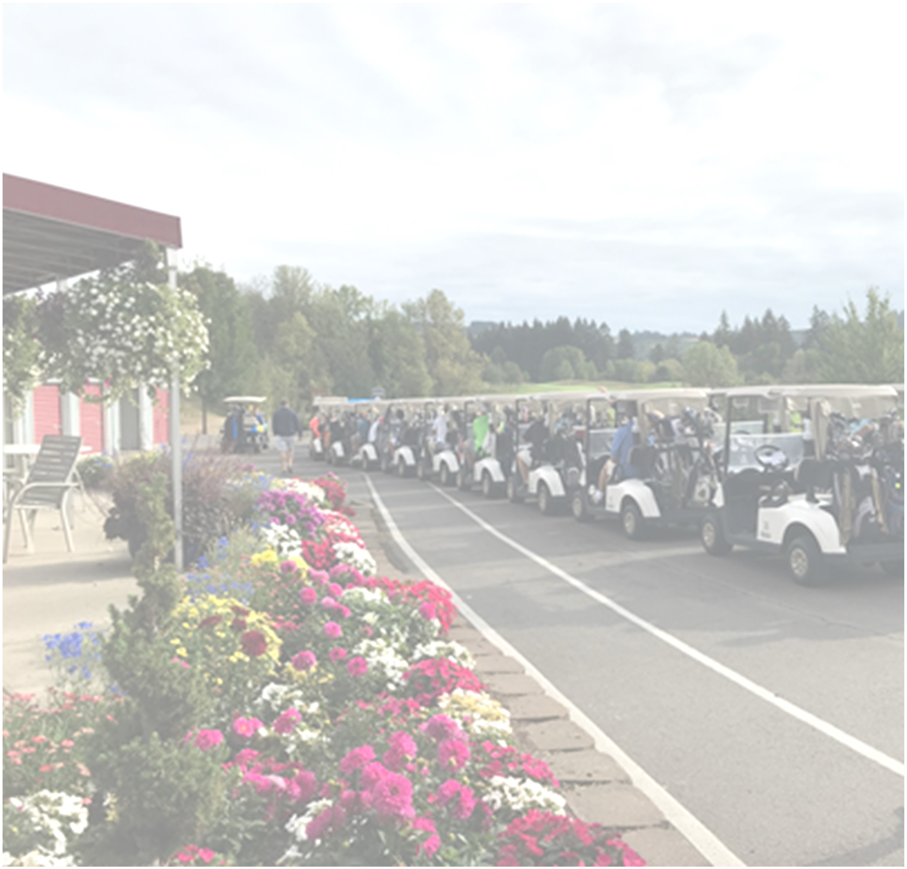
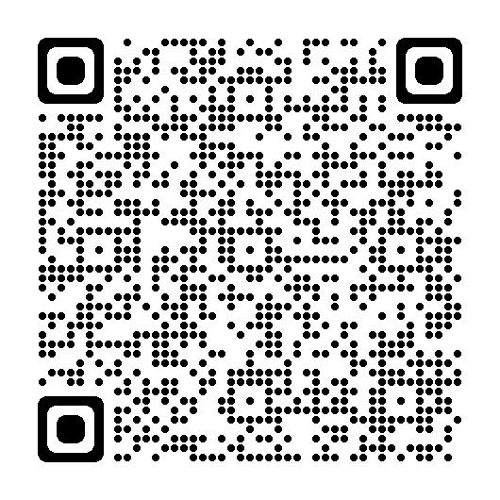


Contact Jen at auctionnhs@gmail.com or (503) 799-6464 with questions
Helicopter Ball Drop 50/50 Raffle
Buy Tickets Online • Do not need to be present to win!
Lunch by La Sierra Catering • On Course Games & Mini Contests

NewbergBoosters.com for more info!

LO TS O F FU N
Sponsors & Golfers Needed!
C O MMU N I TY

