Specialized Plant parts Used in Propagation:

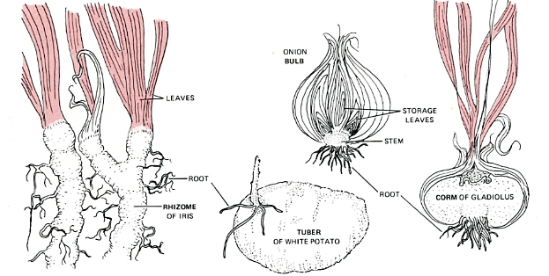

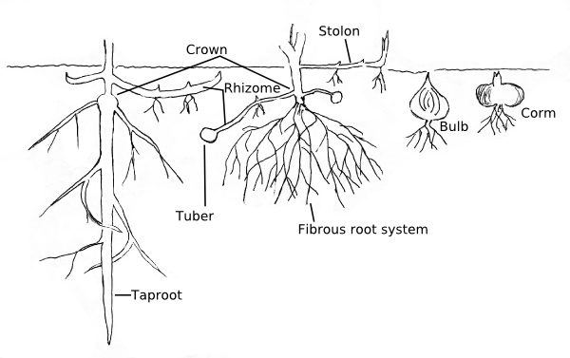

Corms:

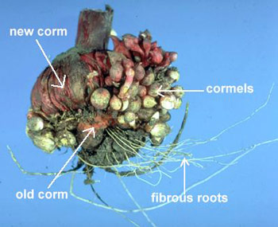A corm is a shortened, fleshy, erect underground stem with inconspicuous scale-like leaves. It closely resembles, and is often mistakenly identified as, a bulb (as the "bulbs" of Gladiolus and Crocus), but actually it is distinguished by being more definitely a modified stem.

A corm is a mass of stem tissues, often bearing a terminal bud on the top and several other lateral buds. Dry leaf bases (similar to tunics) help protect the stem of the corm from harsh weather conditions and lack of moisture. Examples: Gladiolus and Crocus.
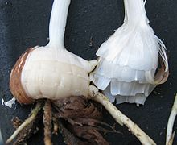Tunic (outer covering) partly removed

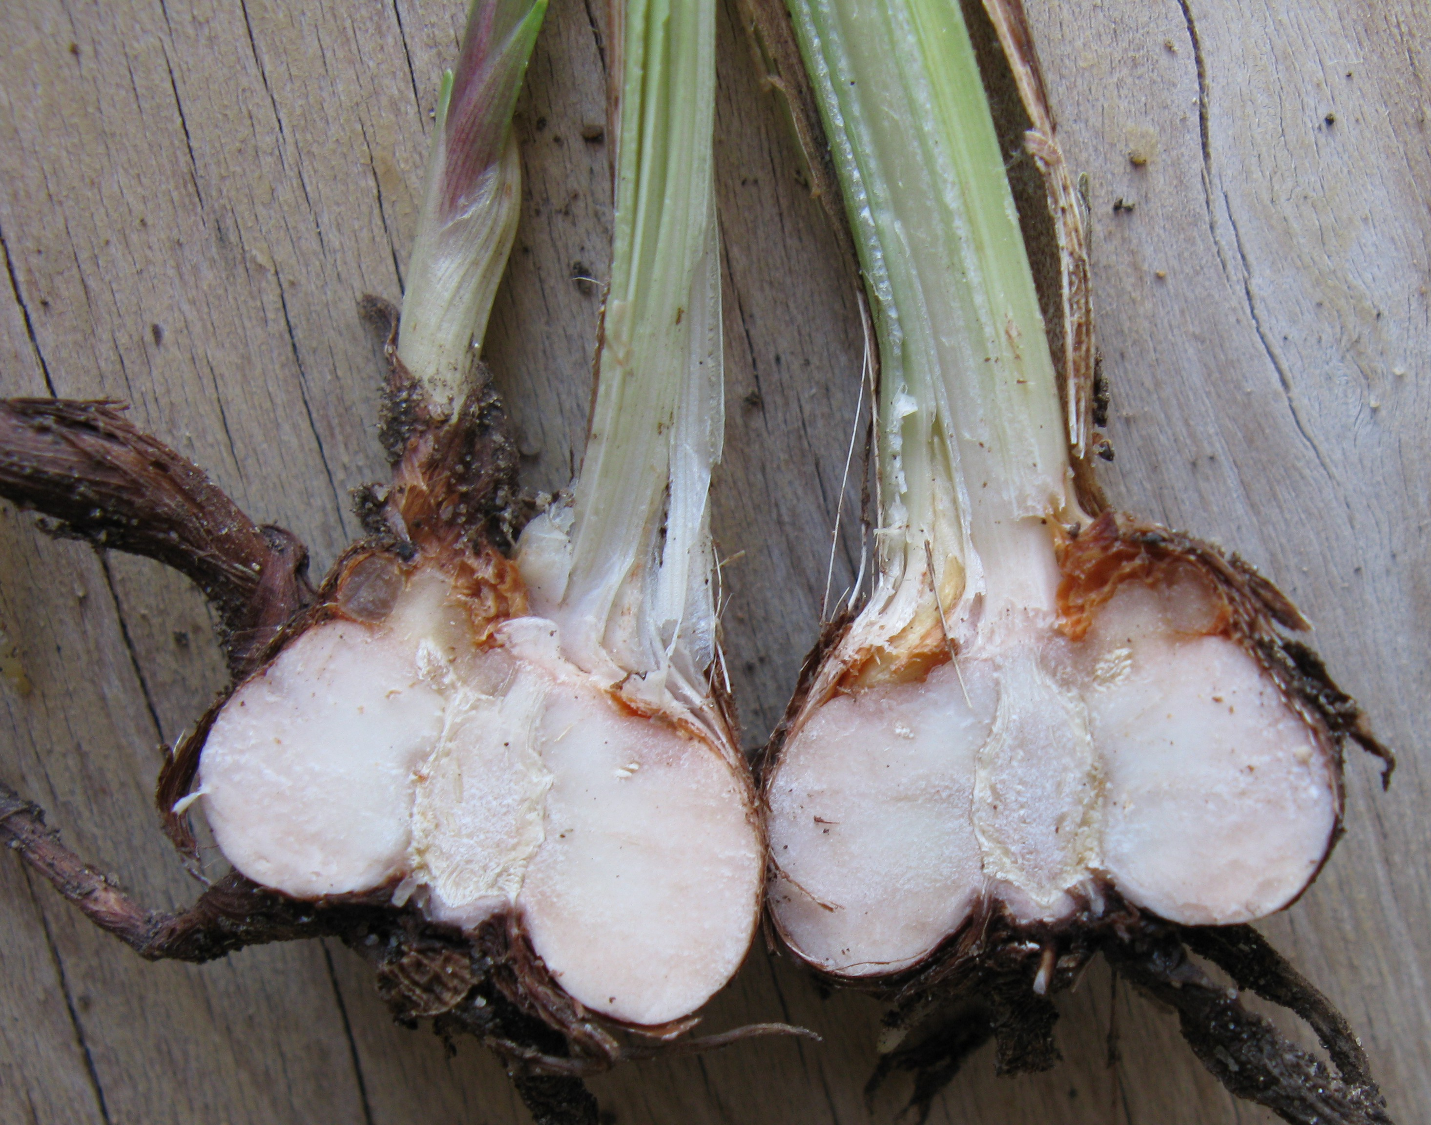

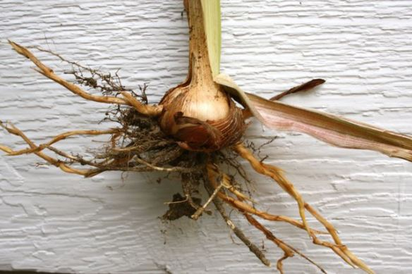
Crocosima Corm

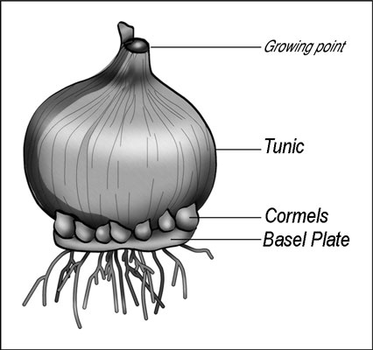
Bulbs:

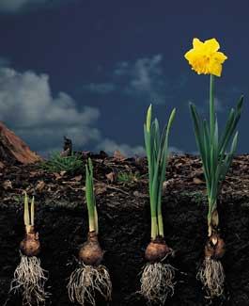Daffodil bulb development through winter

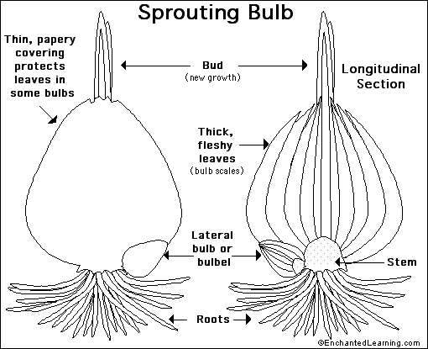
The Bulb:
A bulb is an underground, modified stem that develops in some flowering plants. Its purpose is to store food and water for the plant through a cold or dry season. Examples of bulbs include the tulip, narcissus, crocus, onion, lily, and garlic. The smallest bulbs are the size of peas; the largest (crinum lilies) weigh over 15 pounds (7 kg).

A true bulb is a compressed stem formed from layers of modified leaves that enlarge as they store nutrients. The roots are produced from the bottom of this bulb and the stem will emerge from a growing point at the top. Some bulbs have dry outer scales called a "tunic" that helps protect the inner parts of the bulb from over-drying. Examples: Tulips, Daffodils, Lilies, and Allium.
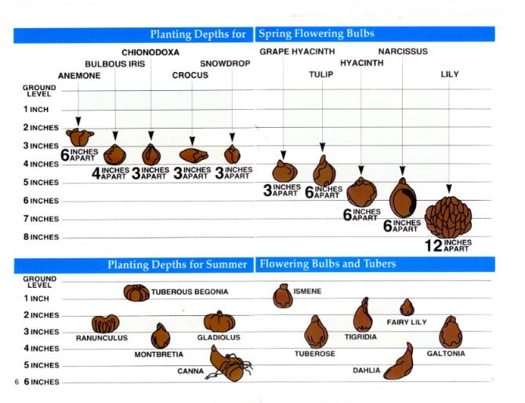

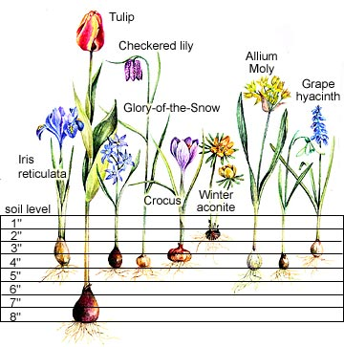
True Tubers and Root Tubers
To put it simply, having a tuber root means that a plant grows a thickened area so it can store nutrition and water during the coming winter. Once winter has passed, the tubers will use the storage units to reproduce themselves.
There are two types of tubers, stem tubers and root tubers. Stem tubers are true tubers and generally grow their storage units from the sides of rhizomes or stolons. Their cell structure is a stem. Stem tubers are usually oblong or somewhat rounded with visible nodes. They are often near the top of the soil. Stem tubers that develop underground are often temporary, and then used to produce young plants. Stem tubers that develop storage units above the ground will drop them to reproduce. A couple examples of stem tubers are the tuberous begonia and cyclamen.
Root tubers, or tuberous roots, are secondary lateral roots. They are quite similar to stem tubers with a few differences. Their cell structure is of root. Another difference is that the end that is attached to the parent has crown tissue where the foliage and stems grow. The roots grow at the other end. With true tubers or stem tubers the end that is attached to the parent is the opposite. Root tubers live for two years, making them biennials. It will live its first year as a tuber. The following year the tubers will grow foliage and flowers. After it is finished blooming, the mother plant will develop tubers as it dies in the fall. Examples of tuberous roots are daylilies, sweet potatoes, and dahlias. Root tubers can be dug up and divided as long as they have a crown.
Modifications of tap roots : In Carrot, Radish and Beet, tap root stores food and becomes fleshy. In carrot, the food storing root becomes conical. It is called conical tap root. In Radish, it becomes fusiform in shape and hence it is called fusiform tap root. In Beet, entire food is stored in the basal part of the root. Hence the root suddenly tapers into a thin threadlike structure. Such a root is called napiform tap root.
Tuberous Roots:

Tuberous roots are true roots which are swollen for food and nutrient storage. The buds are only present at the crown or the stem end of the root with thickened, fleshy tubers scattered along the length of the root. Examples: Dahlias and Ranunculus.

(B) Modifications of adventitious fibrous roots : When a fibrous root stores
food and becomes fleshy, it is called a tuberous root.
In Sweet Potato, a creeper plant, isolated adventitious fibrous roots, developing from
the stem, become tuberous in shape. These roots have irregular shapes and are called simple,
tuberous, roots.
In Asparagus and Dahlia, tuberous roots occur in a cluster. Such clusters are called
fasciculated tuberous roots.

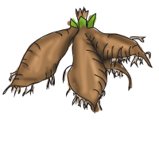
Casava tuberous roots

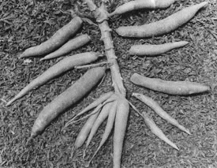
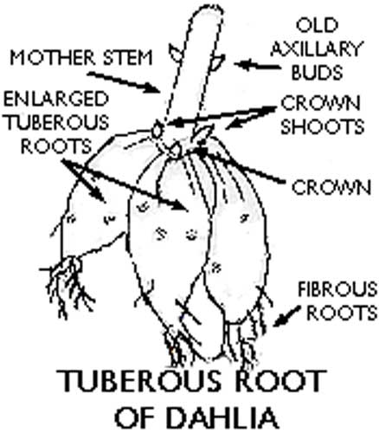

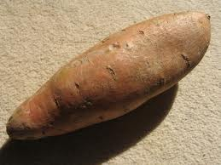Sweet potato tuberous root (notice no eyes)

Tubers:

A tuber is a thickened, underground stem which bears many eyes (buds) on its surface. These tubers systems are covered with a tough skin and often wiry hairs. Tubers grow horizontally to the ground as part of the root system of the plant. Examples: Caladiums, Begonias, and Cyclamen.

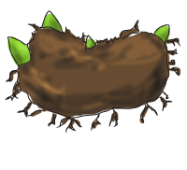

Different types of Tubers

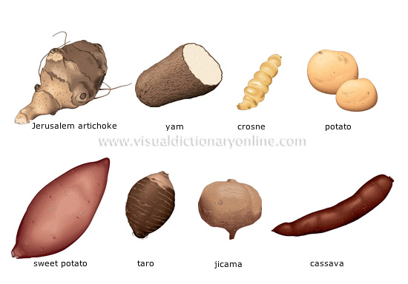


x
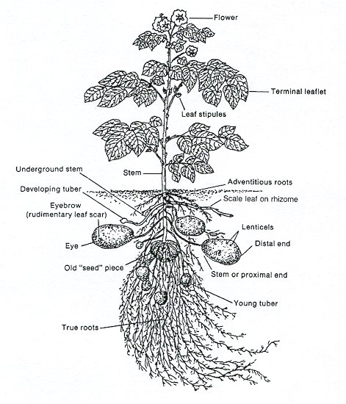

Stolons: 1. A shoot that bends to the ground or that grows horizontally above the ground and produces roots and shoots at the nodes.

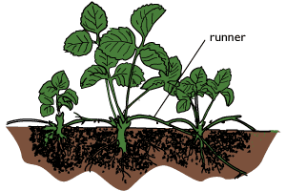

Rhizomes:

Rhizomes are swollen stems which
grow horizontally below or just at the soil's surface. The length of these rhizomes produces multiple eyes (buds) which send shoot above the ground. Roots grow from the underside of these storage organs. Examples: Bearded
Iris and Cannas.

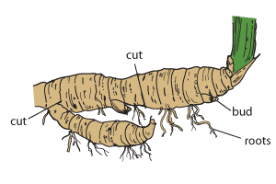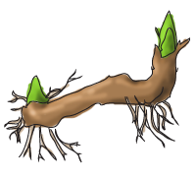

Iris Rhizome



